Project Report

Adaptive Thresholding: Edge Detection in Images

Name: Revanth Kalluri
Course: AI & ML (Batch-5)
Problem Statement: Create an edge detector and use it as a mask to colour edges.

Prerequisites:
Software used and how I installed them:
Python 3.6: Download and install anaconda using https://www.anaconda.com/download/. After installing anaconda, install below modules(packages), using anaconda prompt to run the commands.
Module | Command
matplotlib | pip install matplotlib
cv2 | pip install opencv-python

Pip is a package manager for python packages. Run “pip --version” in anaconda prompt to verify if pip is already installed. Run “conda install pip” to install pip for the first time.

Dataset used:
The data source used for this project is a high illuminated house colour image.

Method used:
Canny edge detection.

1. Importing necessary modules:
2. Read image and covert it to Gray Scale:
3. Apply different edge detection operations:
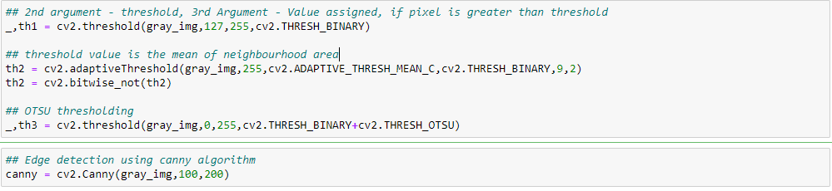
4. Show only edges in colour:
5. Plot all edge detector operations and resultant image:
